Computer Networks Lab-4
Muhammad Hassan Khalid
21L-5692

Lab Statement 1: Capturing FTP packets using Wireshark

Question 5
Port 20 (Data): Handles the actual data transfer. It is only opened when data needs to be sent, then closed after the transfer.
Port 21 (Control): Handles the commands, login details, and responses. It is always open while the session is active.

Question 6
Packet 89:
Type: Response
Response Code: 220
Purpose: The FTP server (195.89.6.167) acknowledges the connection and informs the client that the service is ready for a new user.
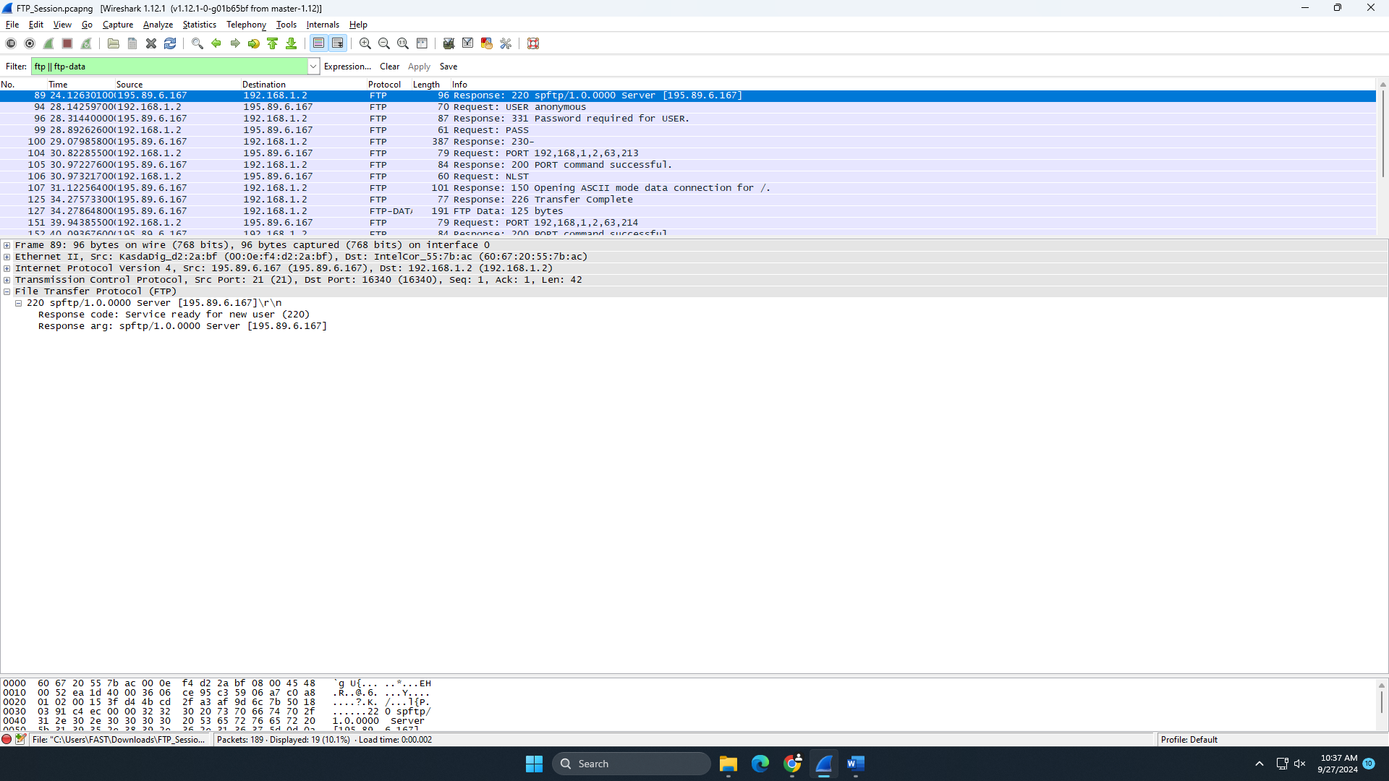
Packet 94:
Type: Request
Request: USER anonymous
Purpose: The client (192.168.1.2) requests to log in using the username "anonymous."
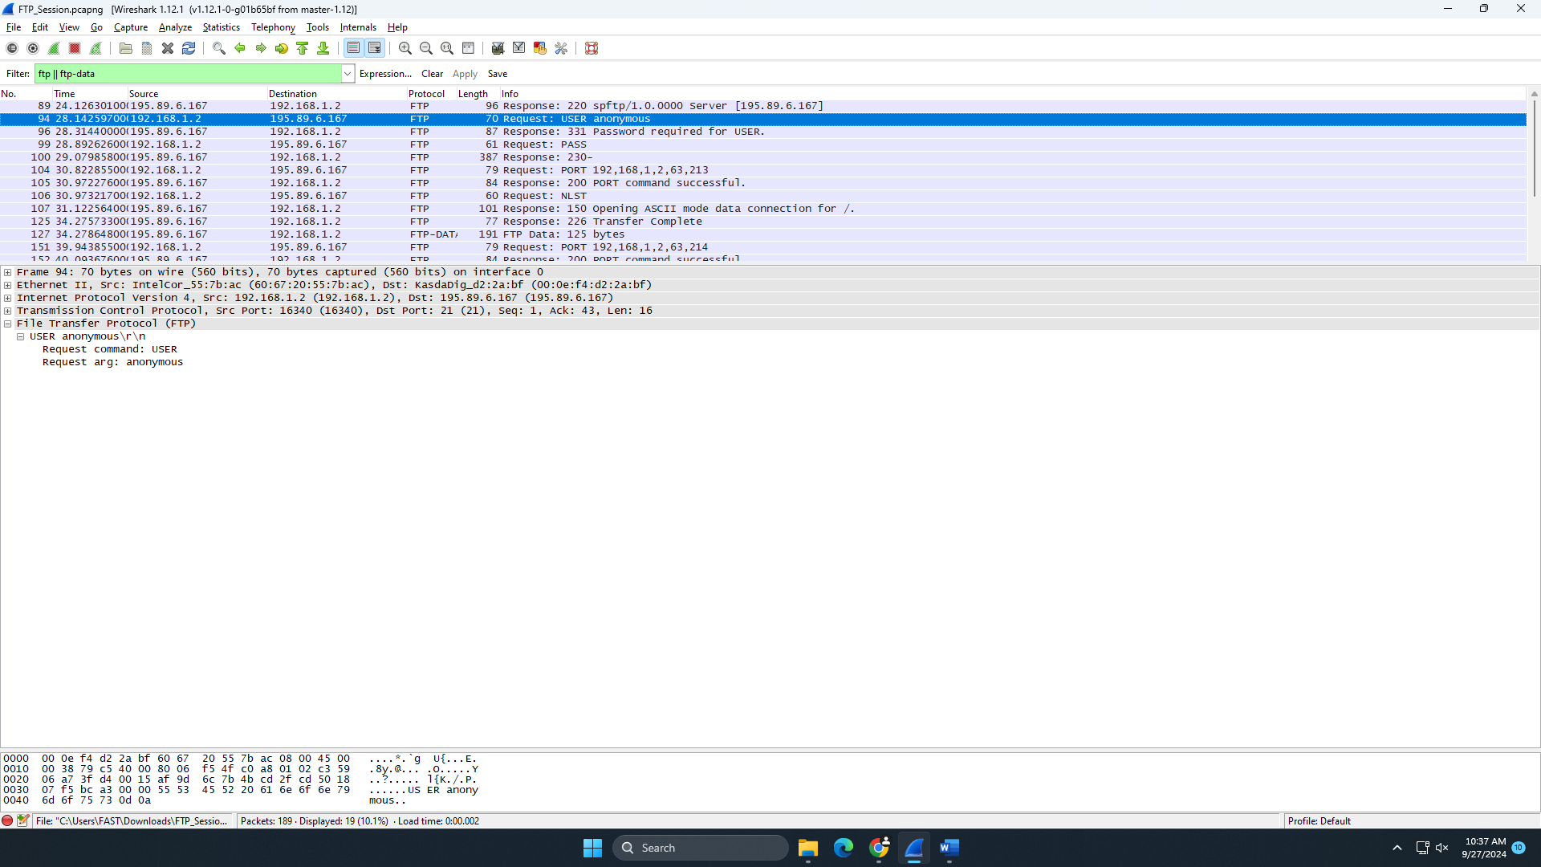

Packet 96:
Type: Response
Response Code: 331
Purpose: The server asks the client to provide a password for the "anonymous" user.
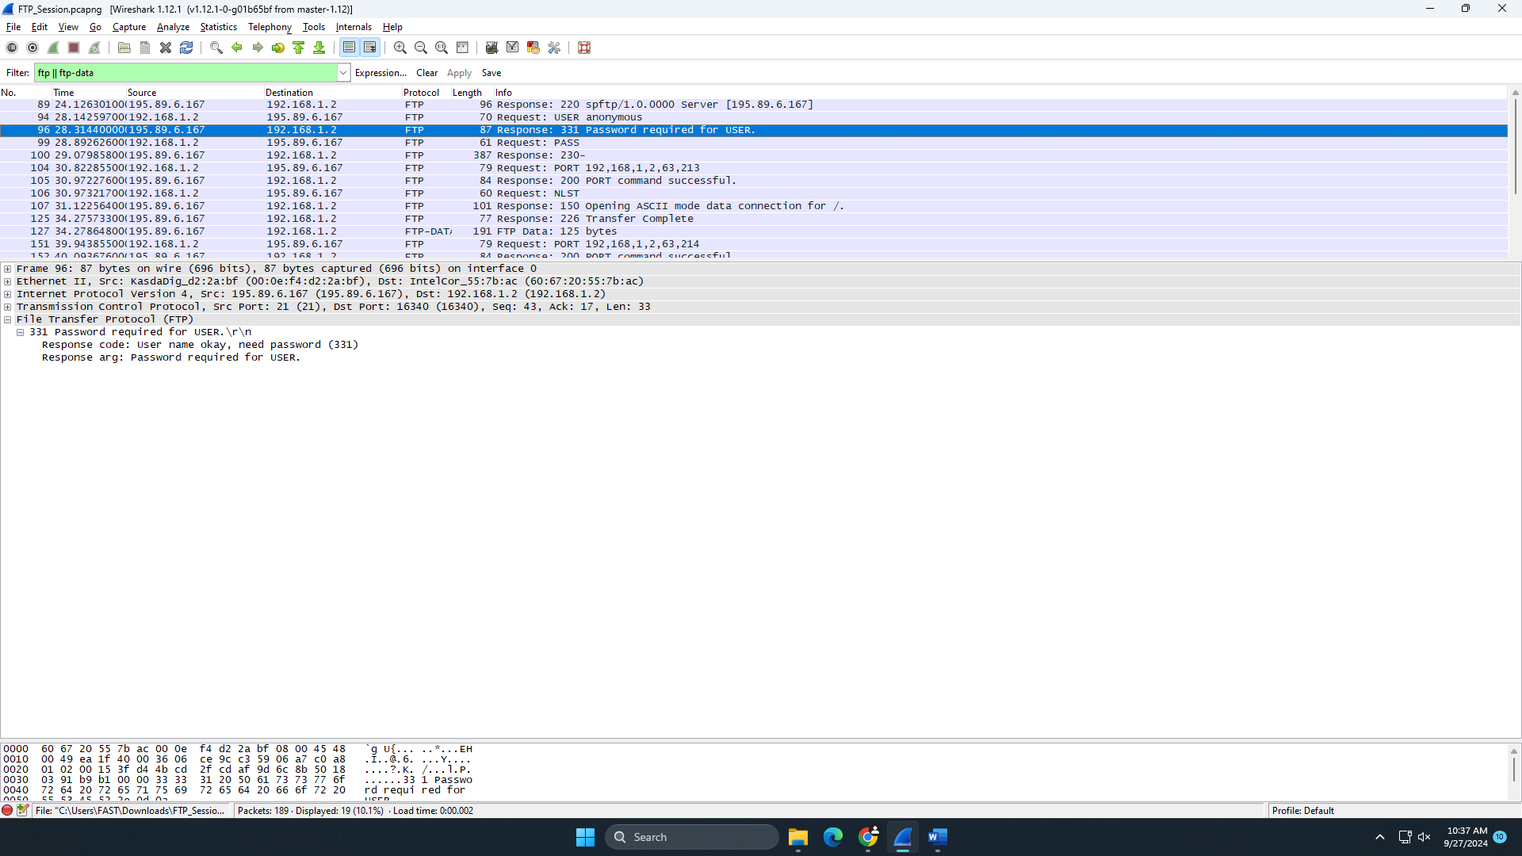

Packet 99:
Type: Request
Request: PASS (empty password)
Purpose: The client attempts to authenticate by sending an empty password (typical for anonymous FTP).
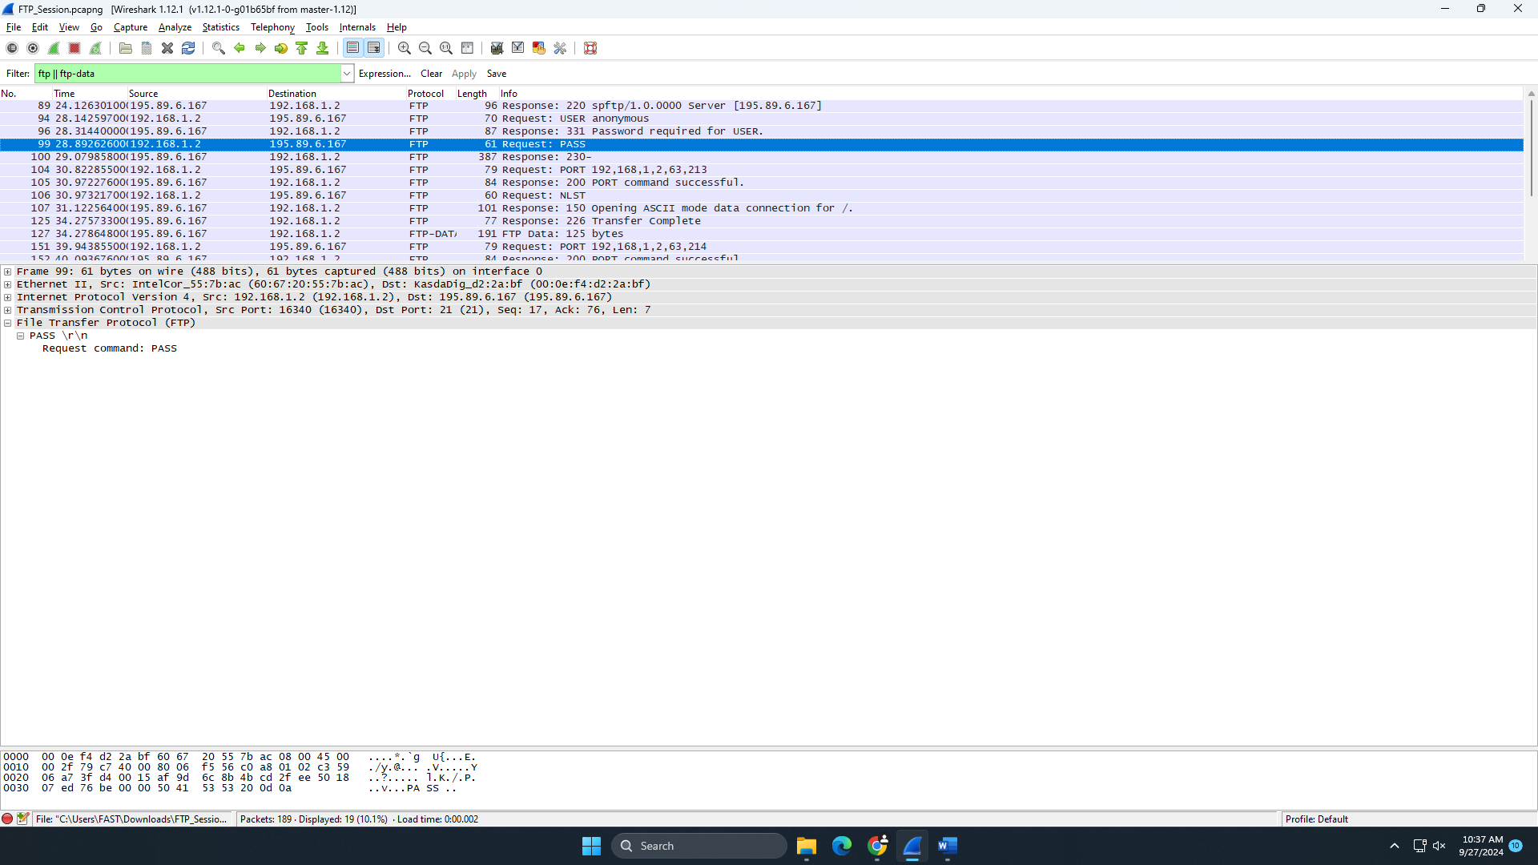

Packet 100:
Type: Response
Response Code: 230
Purpose: The server accepts the login, confirming that the user has logged in successfully.
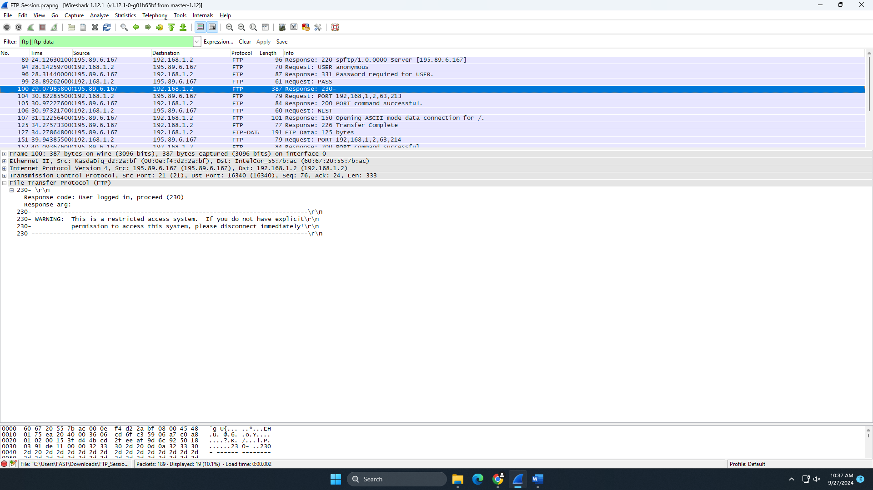
Packet 104:
Type: Request
Request: PORT 192,168,1,2,63,213
Purpose: The client requests the server to establish a data connection to IP 192.168.1.2, port 16341.
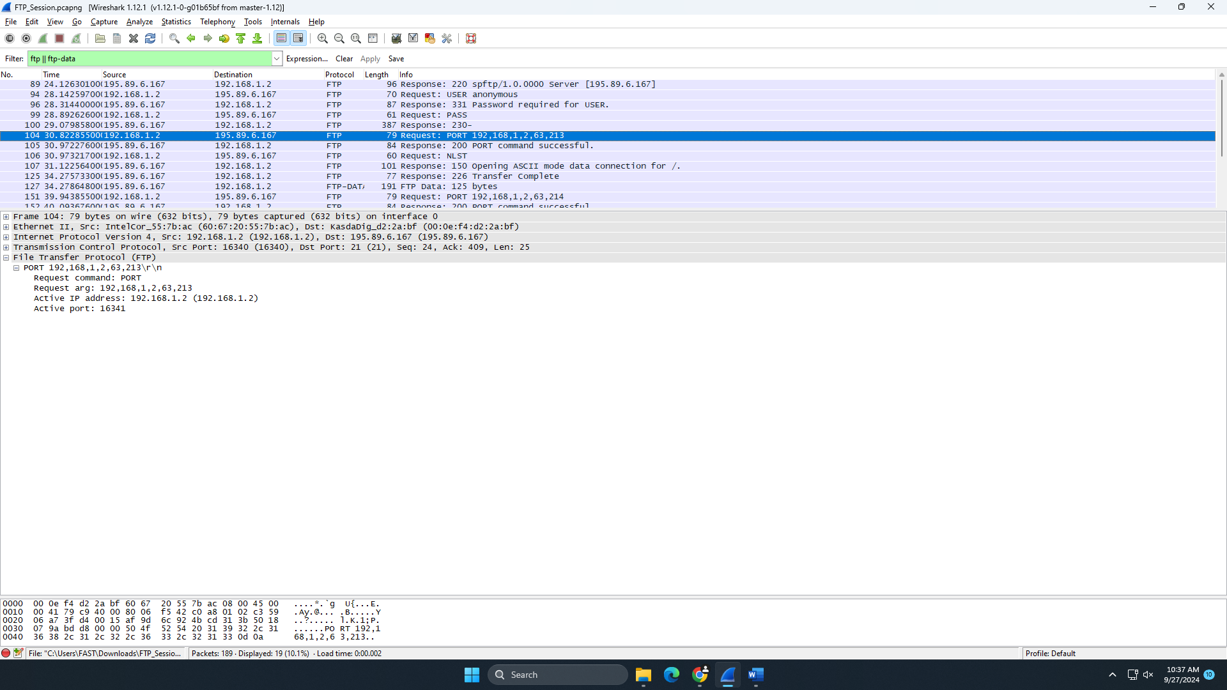
Packet 105:
Type: Response
Response Code: 200
Purpose: The server acknowledges the client's PORT command and confirms that it was successful.
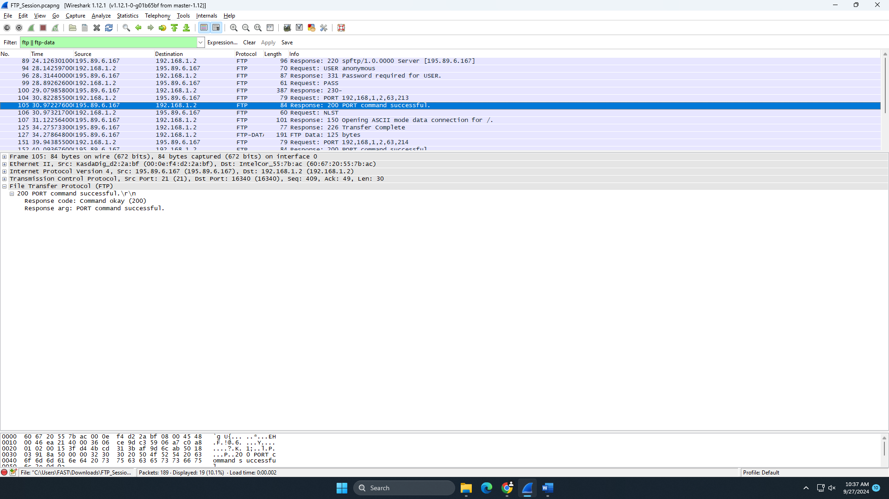
Packet 106:
Type: Request
Request: NLST
Purpose: The client sends the "NLST" command to request a list of filenames in the current directory.
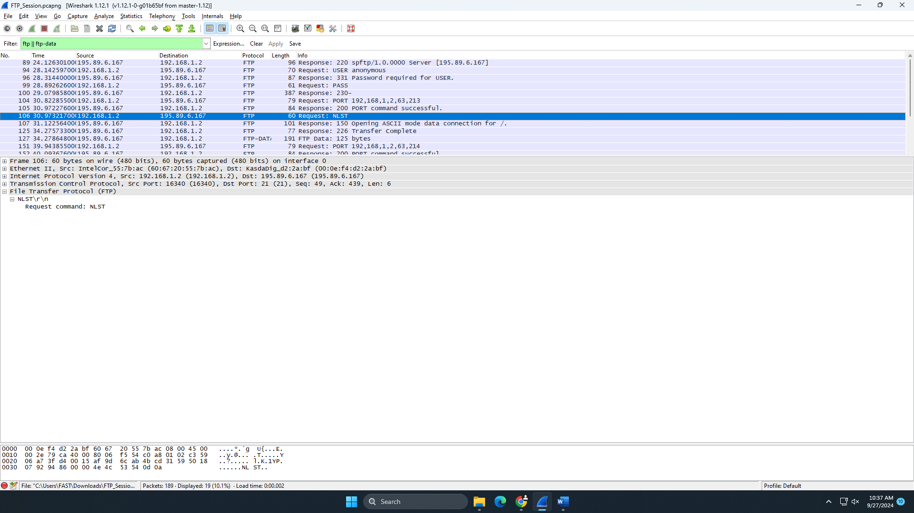
Packet 107:
Type: Response
Response Code: 150
Purpose: The server responds, indicating that it is about to open a data connection to transmit the requested file list.
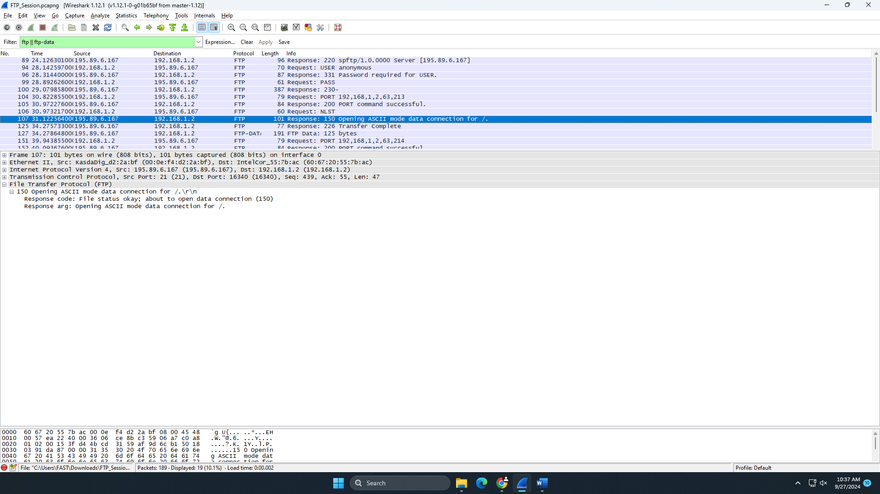
Packet 125:
Type: Response
Response Code: 226
Purpose: The server informs the client that the transfer of the file list is complete.
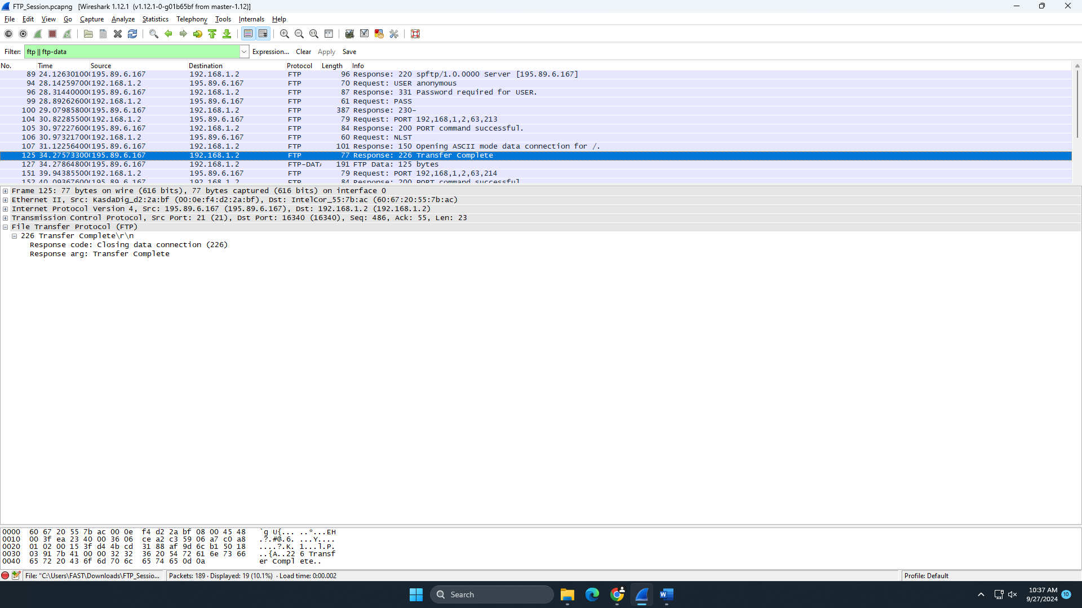
Packet 127:
Type: FTP-DATA
Purpose: The server sends the list of files in the directory to the client over the established data connection.
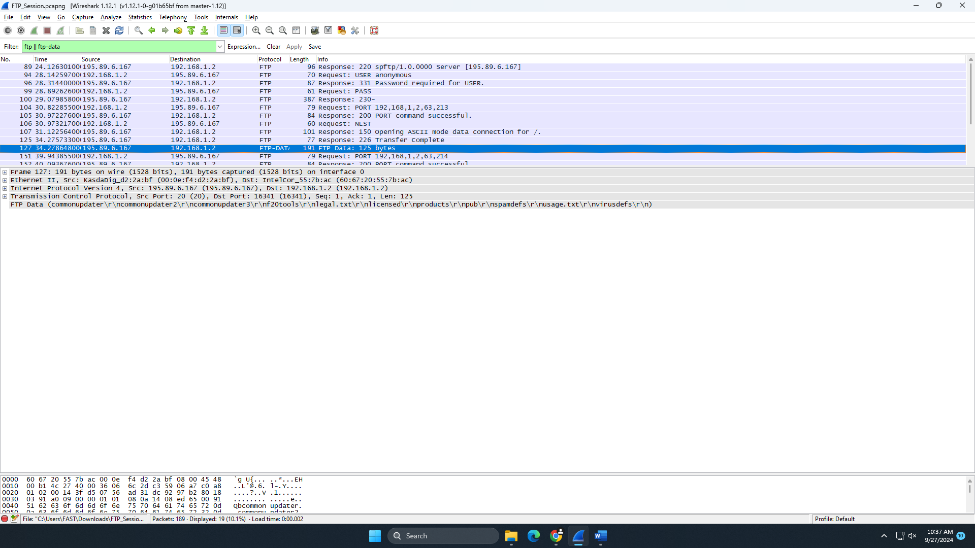
Packet 151:
Type: Request
Request: PORT 192,168,1,2,63,214
Purpose: The client requests a new data connection to IP 192.168.1.2, port 16342 for file transfer.
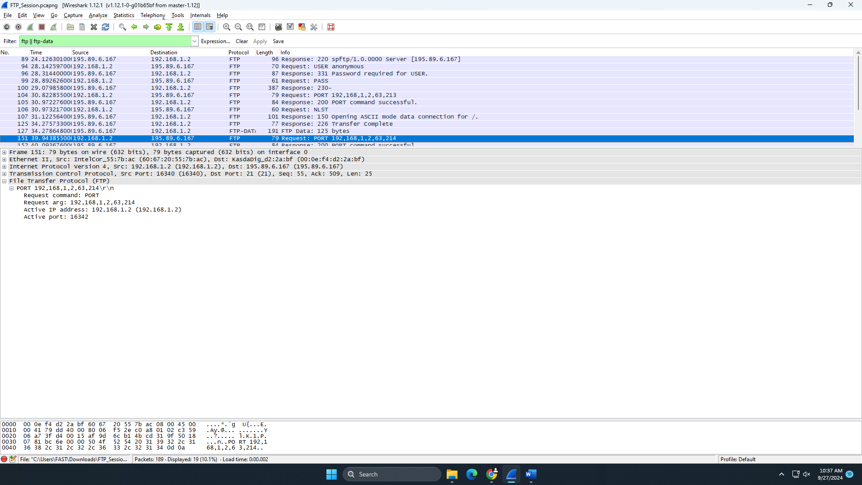
Packet 152:
Type: Response
Response Code: 200
Purpose: The server confirms that the new data connection has been successfully established.
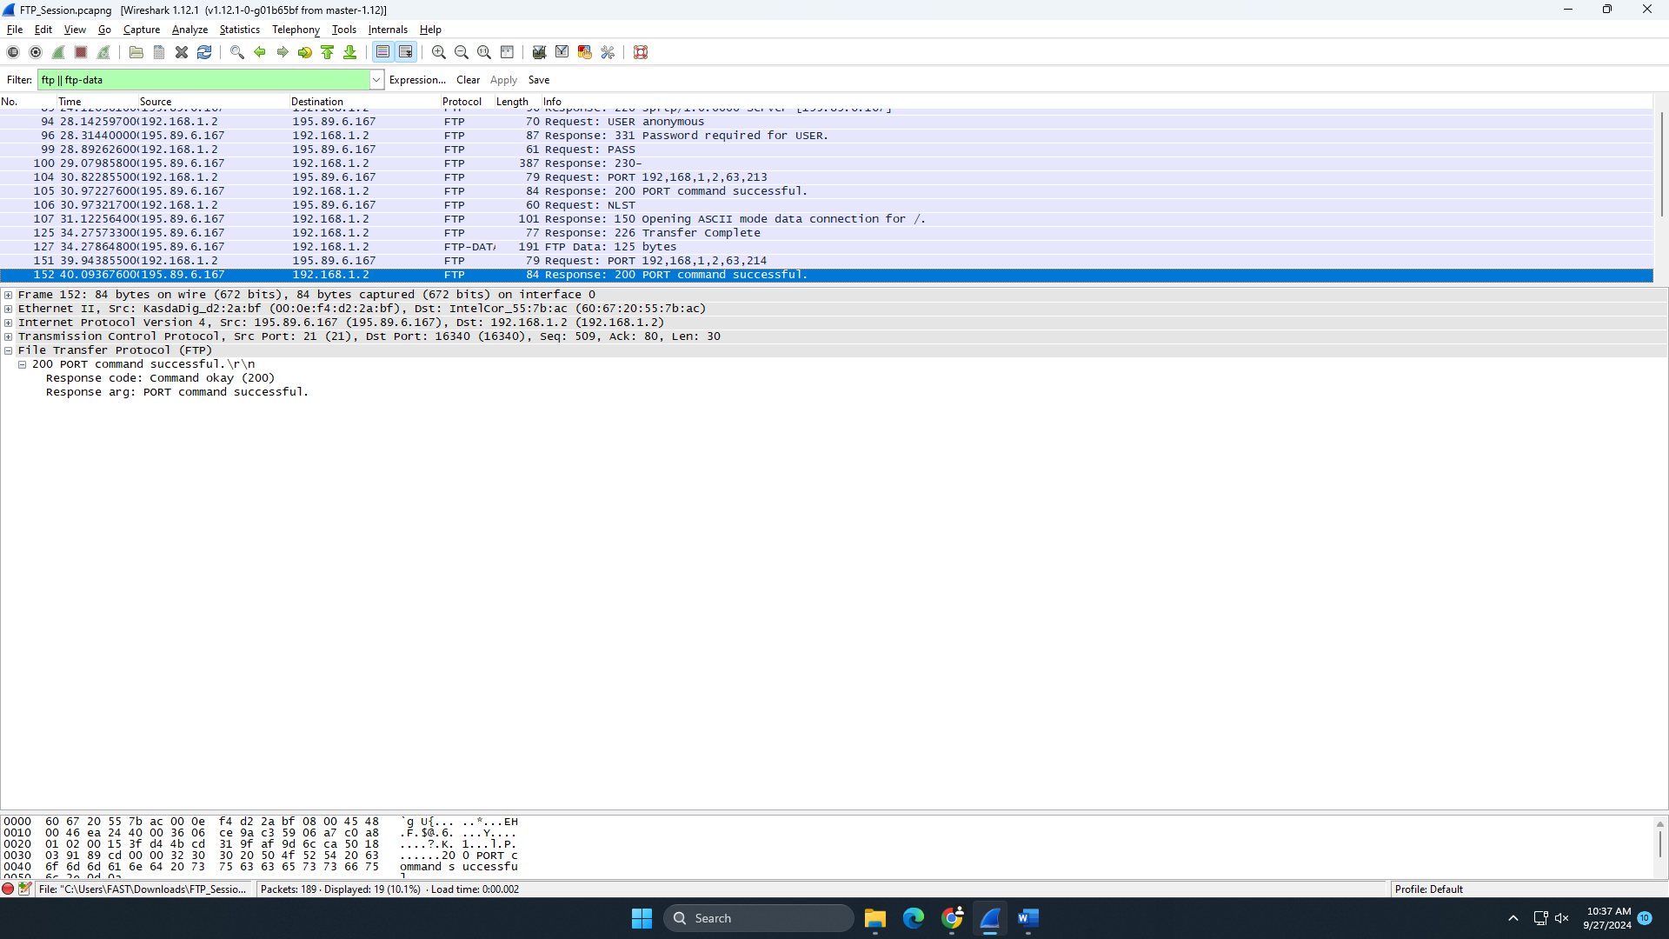
Packet 153:
Type: Request
Request: RETR legal.txt
Purpose: The client requests the server to transfer the file legal.txt.
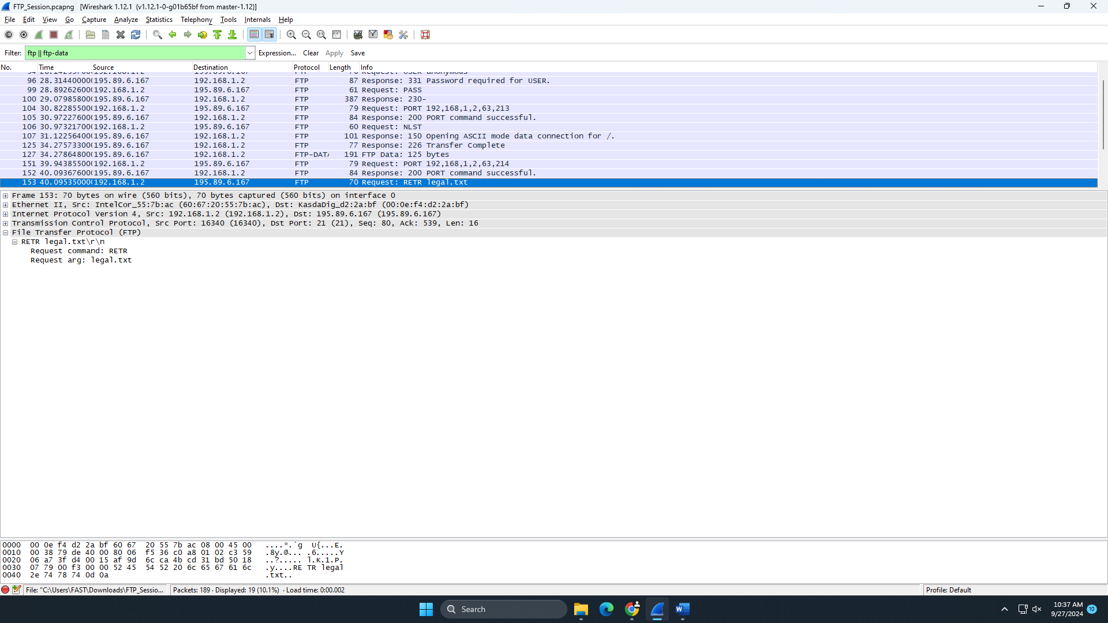
Packet 155:
Type: Response
Response Code: 150
Purpose: The server responds, indicating it is about to open the data connection for transferring the requested file.
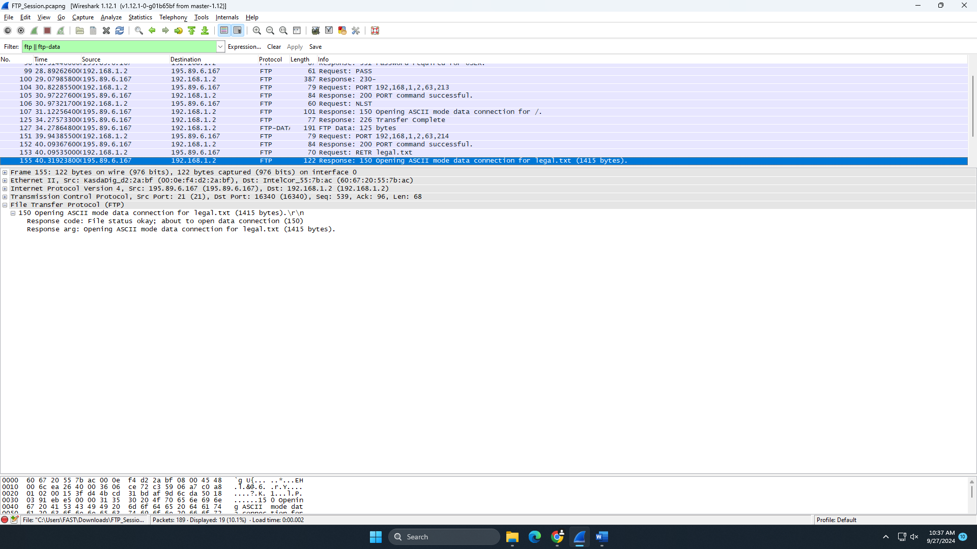
Packet 160:
Type: Response
Response Code: 226
Purpose: The server informs the client that the transfer of legal.txt is complete.
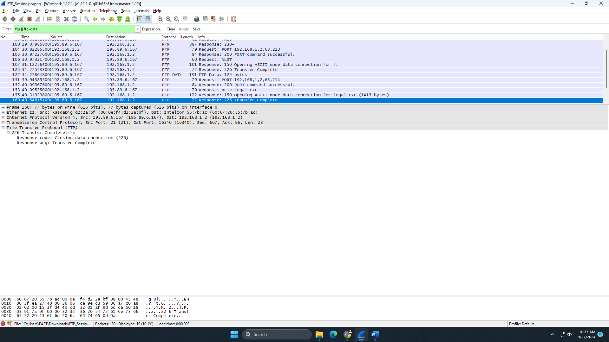
Packet 161:
Type: FTP-DATA
Purpose: The server transfers the file legal.txt (1415 bytes) to the client over the data connection.
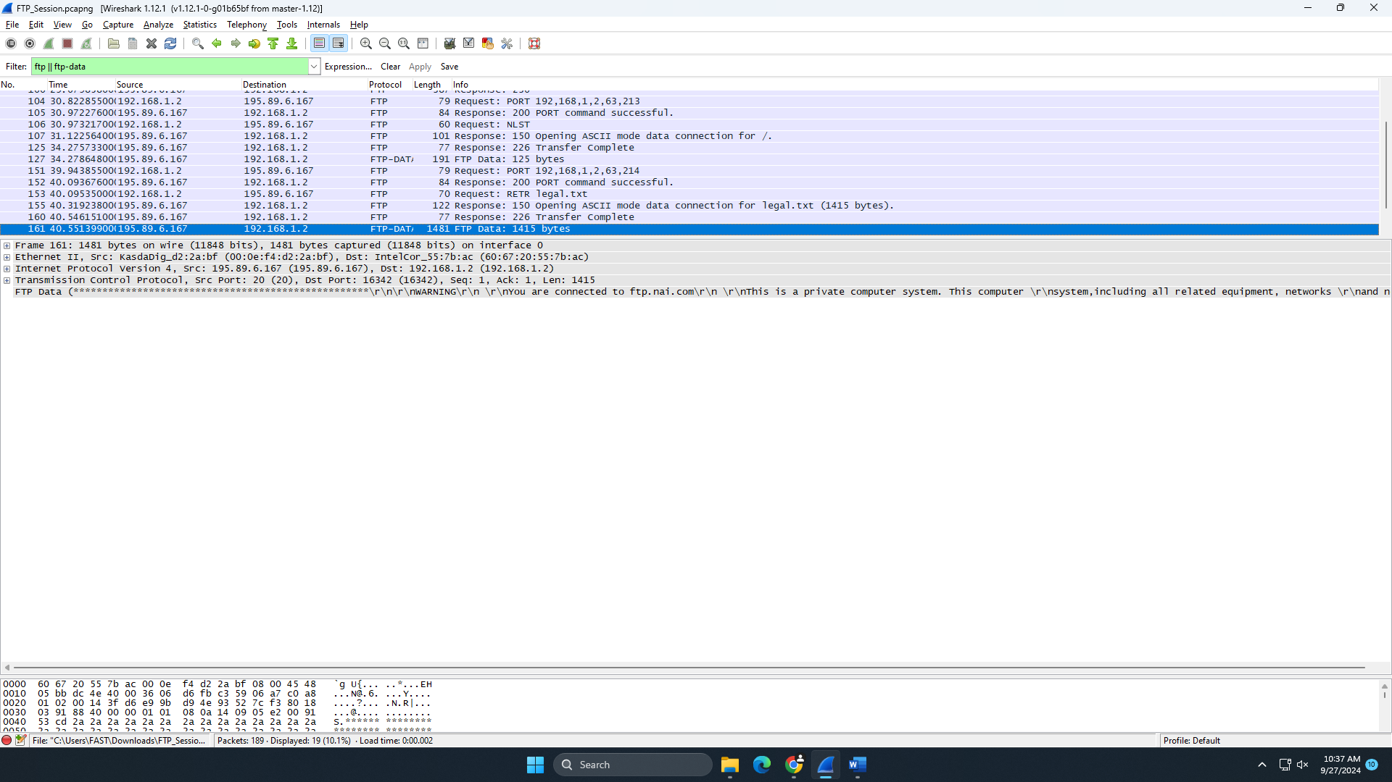
Packet 173:
Type: Request
Request: QUIT
Purpose: The client sends a request to close the FTP session.
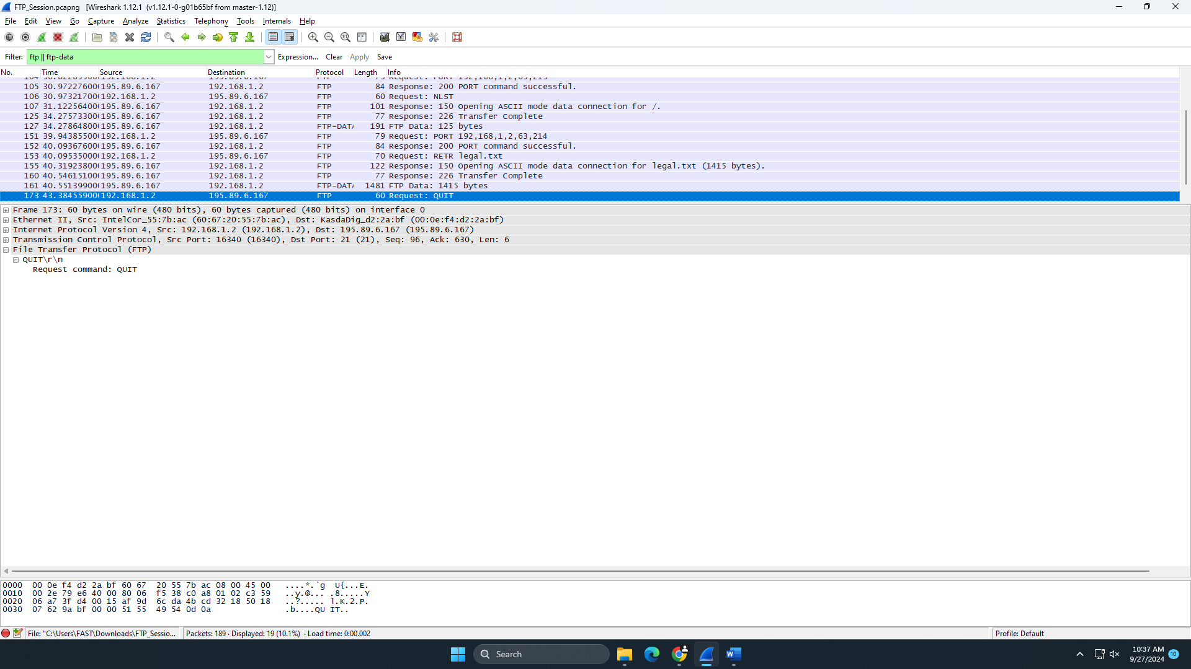
Packet 175:
Type: Response
Response Code: 221
Purpose: The server acknowledges the QUIT command and closes the FTP session.
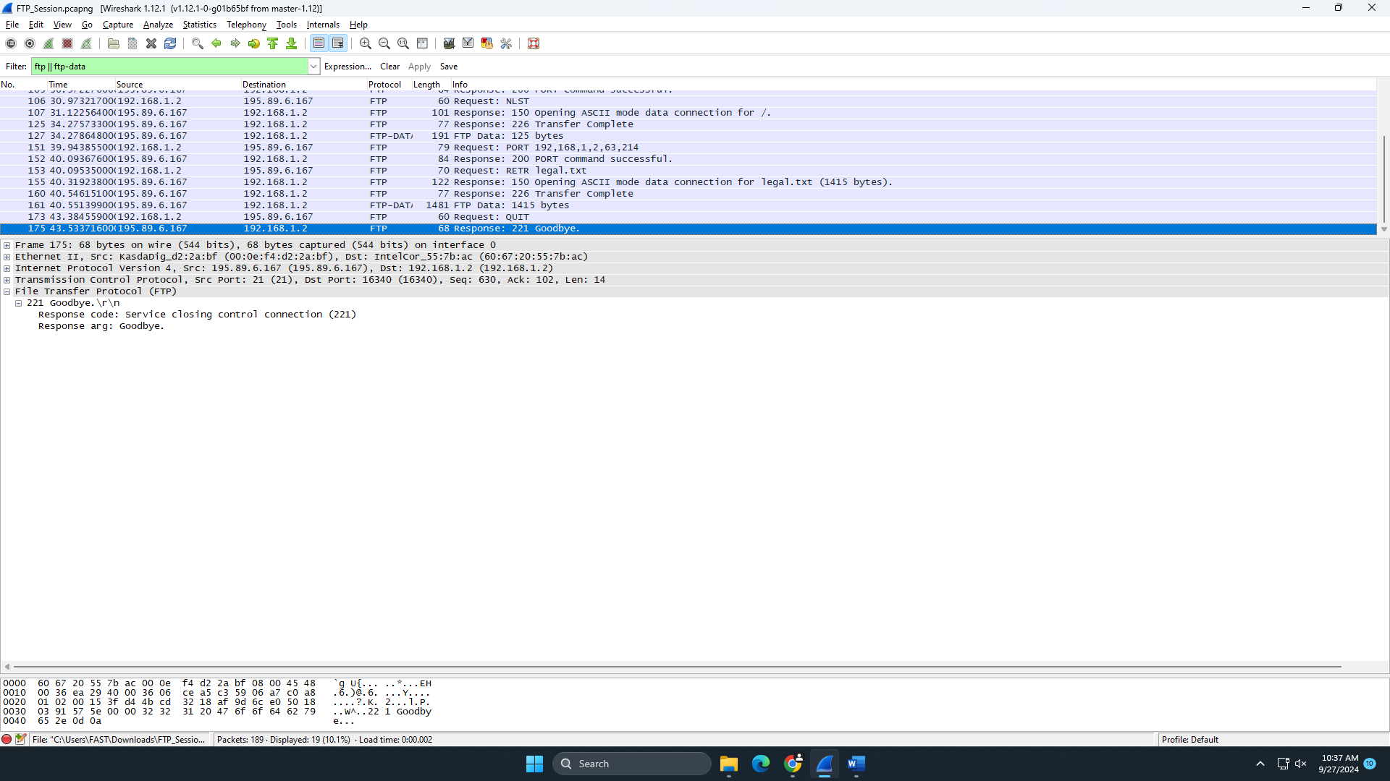
Lab Statement 2: Analyzing ICMP Packets

- Are ICMP messages sent over UDP or TCP?
ICMP messages are sent directly over IP and not over UDP or TCP. ICMP is a part of the IP layer and is used for error reporting and diagnostics.
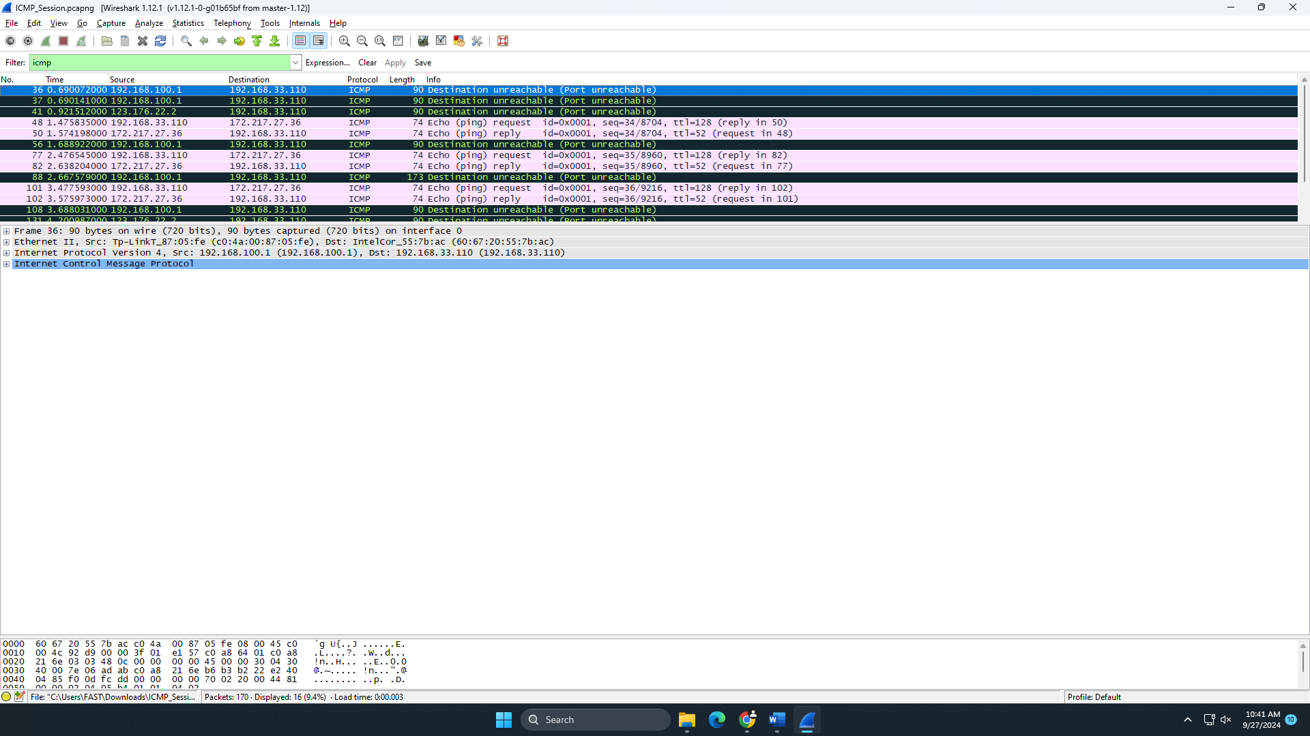
- What is the link-layer (e.g., Ethernet) address of the host?
The Ethernet address (MAC) of the host can be observed in the packets. For example, the source MAC address of the host is Intel_55:7b:ac (60:67:20:55:7b:ac).
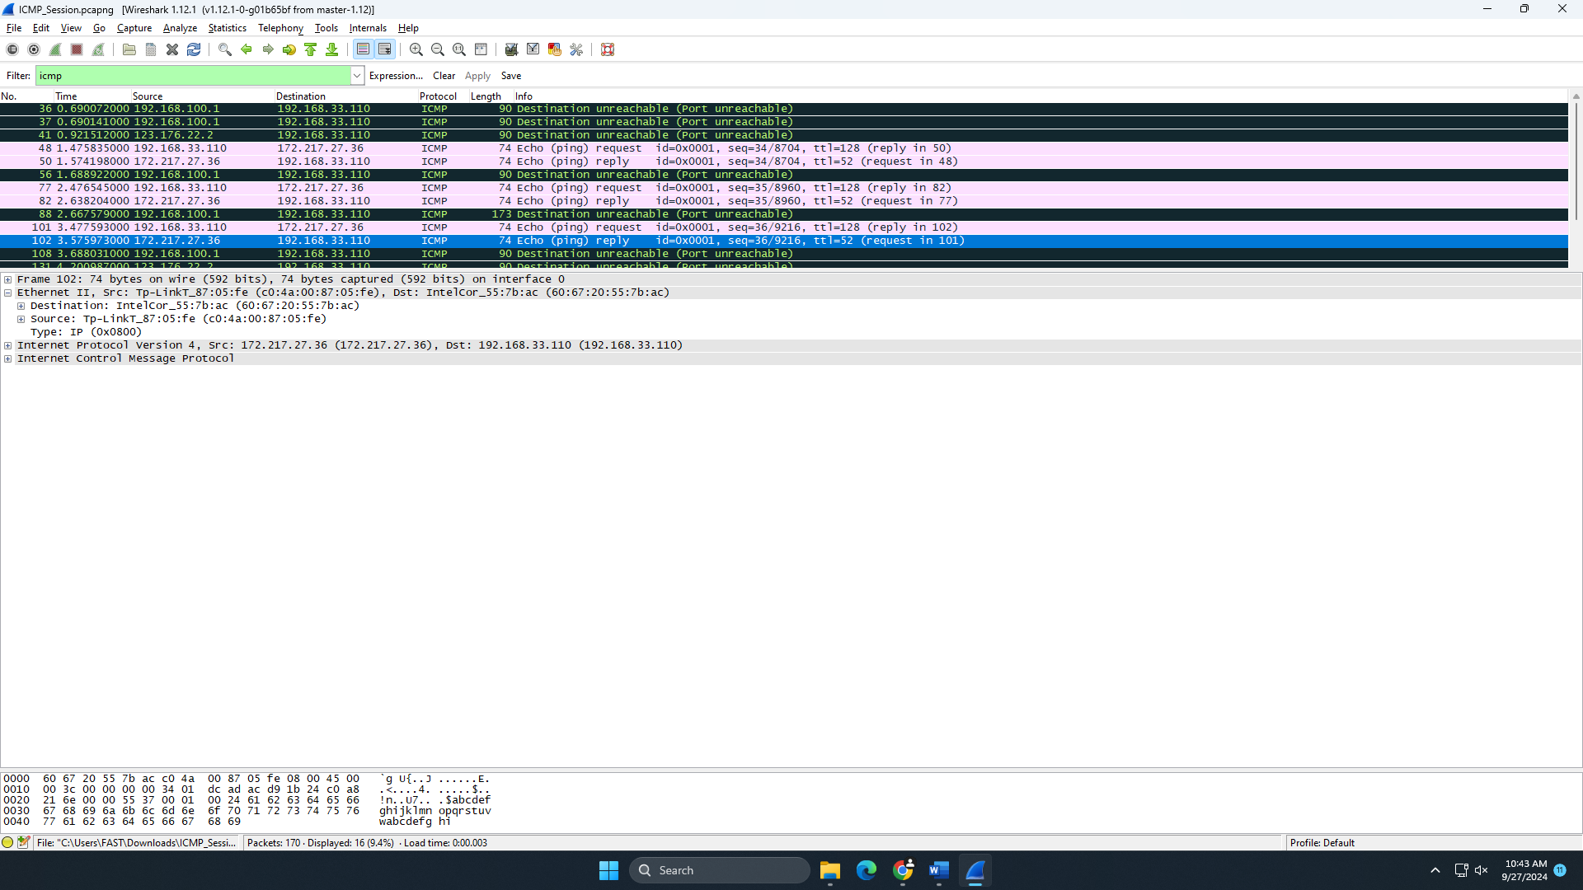
- Which kind of request is sent through these ICMP packets?
The ICMP packets are primarily echo (ping) requests and replies. For instance, Frame 48 contains an echo request (ICMP Type: 8).
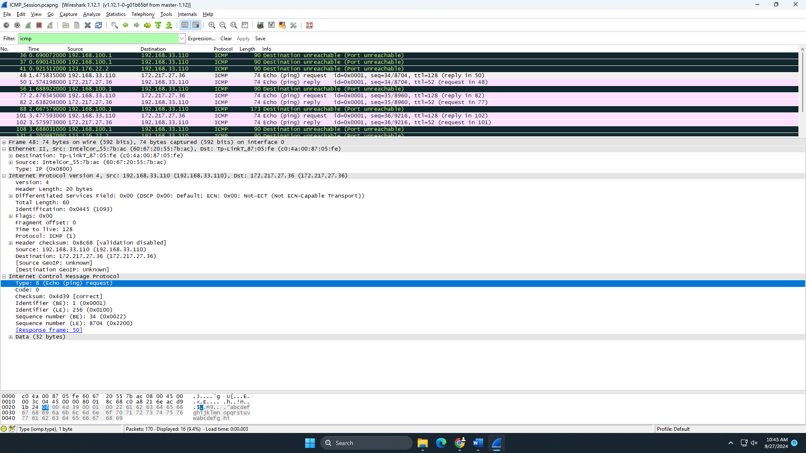
- How many requests are sent through the host?
Based on the captured packets, multiple echo requests are sent, such as in Frames 48, 77, 101, and 135.
- What is the IP address of your host? What is the IP address of the destination host?
Host IP address: 192.168.33.110.
Destination IP addresses vary; for example, in Frame 48, the destination is 172.217.27.36.
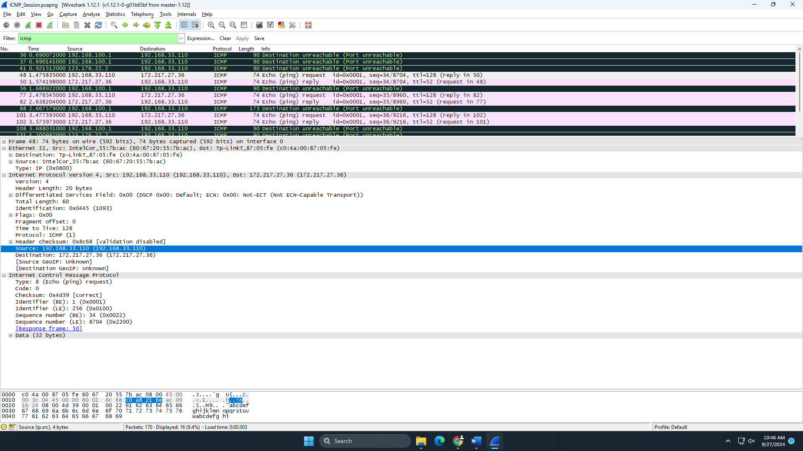
- Why is it that an ICMP packet does not have source and destination port numbers?
ICMP is a network layer protocol used for control messages, unlike TCP/UDP, which operate at the transport layer and use ports for communication. ICMP only involves IP addresses for routing, so ports are unnecessary.
- What values in the ICMP request message differentiate this message from the ICMP reply message?
The type and code fields differentiate ICMP request and reply messages. The echo request (ping) has Type 8 and Code 0, while the echo reply has Type 0 and Code 0.
- Examine one of the ping request packets sent by your host. What are the ICMP type and code numbers? What other fields does this ICMP packet have? How many bytes are the checksum, sequence number, and identifier fields?
From Frame 48:
ICMP Type: 8 (Echo request).
ICMP Code: 0.
The ICMP packet includes fields such as Checksum, Sequence Number, and Identifier.
The checksum, sequence number, and identifier fields are each 2 bytes (16 bits).

- Examine the corresponding ping reply packet. What are the ICMP type and code numbers? What other fields does this ICMP packet have? How many bytes are the checksum, sequence number, and identifier fields?
From Frame 50:
ICMP Type: 0 (Echo reply).
ICMP Code: 0.
The ICMP packet contains similar fields as the request: checksum, sequence number, and identifier, each 2 bytes.
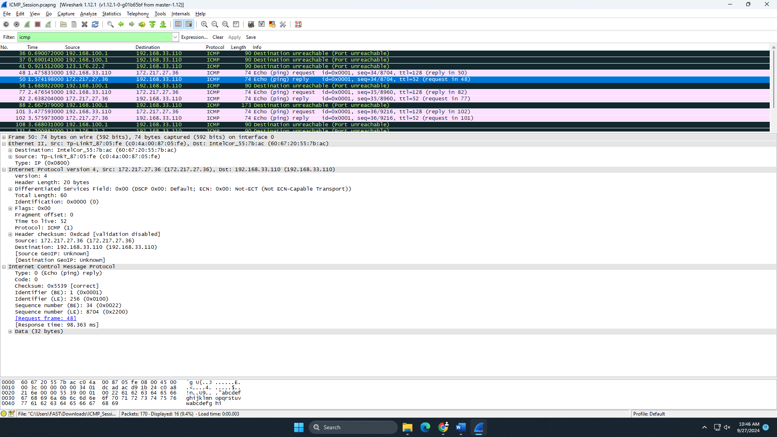
- Examine packet no. 56. What are the ICMP type and code numbers? Why are the IP and TCP headers included in the ICMP header? What do these headers depict?
Frame 56 is a "Destination unreachable" message:
ICMP Type: 3 (Destination unreachable).
ICMP Code: 3 (Port unreachable).
The IP and TCP headers are included to provide context to the recipient about which connection the error message relates to, depicting the original request that led to the unreachable destination. These headers allow the original packet to be identified.
